**Airline Data Management and Analysis Using Power BI**

**Course: Data Visualization with Power BI**

**Name: Ravi Kant**

**Project Overview**

This project is part of the **Data Visualization with Power BI** course and focuses on analysing and visualize airline data for operational insights, passenger management, and ticket booking trends using Power BI.

**Datasets Used:**

[**Flight_Information**](https://docs.google.com/spreadsheets/d/1PwnpBEUiG5A-tEKgxnjKsEmud4ZzUKT2yV5WgMHxrPk/edit?gid=1262897191#gid=1262897191)[**Ticket_Information**](https://docs.google.com/spreadsheets/d/1Z2E6tvuZodoru_h52cFQWrMZTkf69ynyai8KjPKRDkk/edit?gid=435997425#gid=435997425)[**Passenger_Information**](https://docs.google.com/spreadsheets/d/1p3K0MWxbzDp1T8FJ168Hgw7WDnEURzvFxhPhEdmqqzI/edit?gid=1870640173#gid=1870640173)

1. **Flight Information:** Includes FlightID, FlightNumber, Airline, Destination, and Status.

2. **Passenger Information:** Includes PassengerID, FlightID, and SeatNumber.

3. **Ticket Information:** Includes TicketID, FlightID, and BookingStatus.

**Methodology**

Importing the Dataset

* Open Power BI Desktop.
* Click on Get Data → excel workbook.
* Load the dataset into Power BI all three data.

**Tasks (1)**

**1. Data Preparation and Cleaning.**

* Extract and transform data in Power Query.
* Clean data: remove duplicates, handle missing values, and format columns.
* Deliverables: Screenshot of Power Query Editor showing cleaned data.

**Explication: (1)**

**1.1 Extracting and Loading Data**

Open Power BI Desktop.

Navigate to Home → Get Data → Excel/CSV (or your data source).

Select the relevant datasets:

Flight_Information

Passenger_Information

Ticket_Information

Click Transform Data to open Power Query Editor.

**2.1 Data Cleaning Steps in Power Query**

In Power Query, perform the following cleaning steps:

a): Remove Duplicates

select all columns of data (Flight_information, Passenger_information and Ticket_information).

Go to Home 🡪 Remove rows 🡪 Remove duplicates.

**2.2: Handle Missing Values**

Identify missing values using Transform 🡪 Replace Values or Remove Rows 🡪 Remove Blank Rows but there are no missing values in the data.

**2.3 Format Columns**

Select data in power query editor 🡪 In the left of every column there is format option.

Format FlightNumber, PassengerID, and TicketID as Text

For numeric values, set appropriate data types like Whole Number or Decimal Number.

**3.1** cleaned data of **Flight_Informatin:**

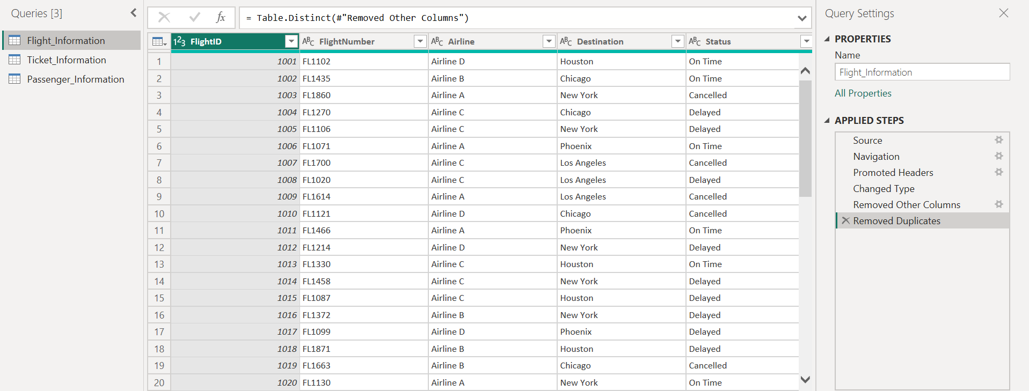

**3.2** cleaned data of **Ticket_Information:**

**3.3** cleaned data of **Passenger_Information:**

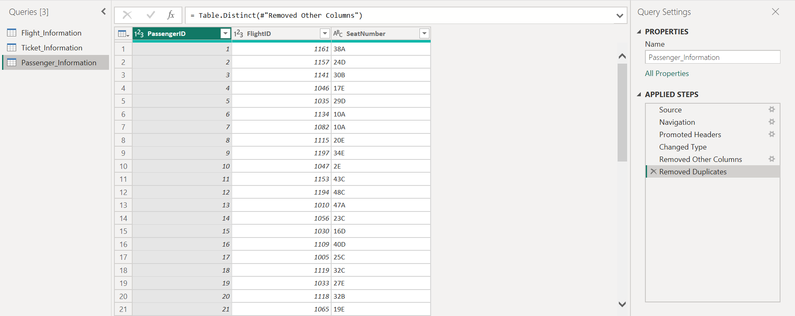

**Tasks (2)**

2. Data Modelling

● Create relationships between datasets (FlightID as the key).

● Understand cardinality and configure the model appropriately.

● Deliverables: Screenshot of the data model with relationships.

**Explication: (2)**

1. Creating Relationships in Power BI
2. Go to the Model View in Power BI.
3. Establish relationships between the datasets:
4. Flight_Information[FlightID] → Passenger_Information[FlightID]
5. Flight_Information[FlightID] → Ticket_Information[FlightID]
6. The cardinality is One-to-Many for these relationships.

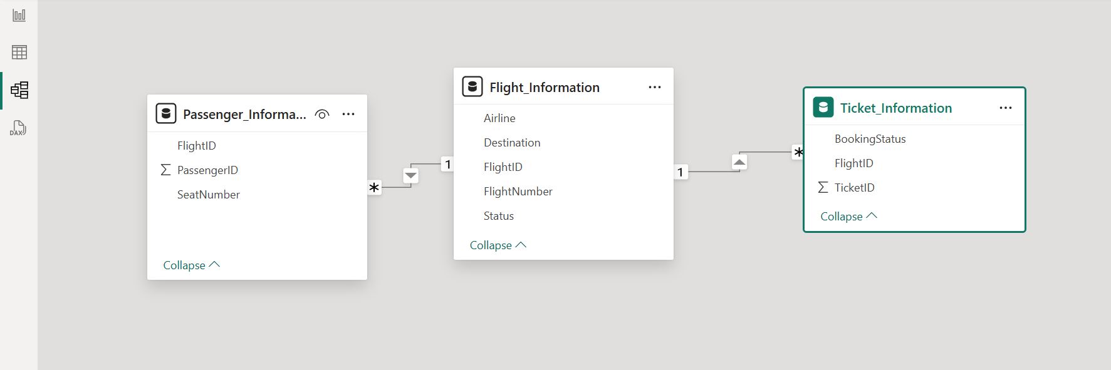

**Tasks (3)**

3. Enhanced Data Insights

● Add a conditional column to classify flights as "Best" or "To Be Improved" based on status.

● Use "Column from Examples" to extract the flight number from FlightNumber.

● Deliverables: Screenshot of the transformed data.

**Explication: (3)**

1. In Power BI Desktop, go to Transform Data to open Power Query Editor.
2. Add a Conditional Column

In Power Query, go to the Add Column tab.

Select Conditional Column.

In the dialog box:

Column Name: Flight_Classification

Condition:

If Status = "On Time" → Then "Best"

Else "To Be Improved"

Click OK to add the new column.

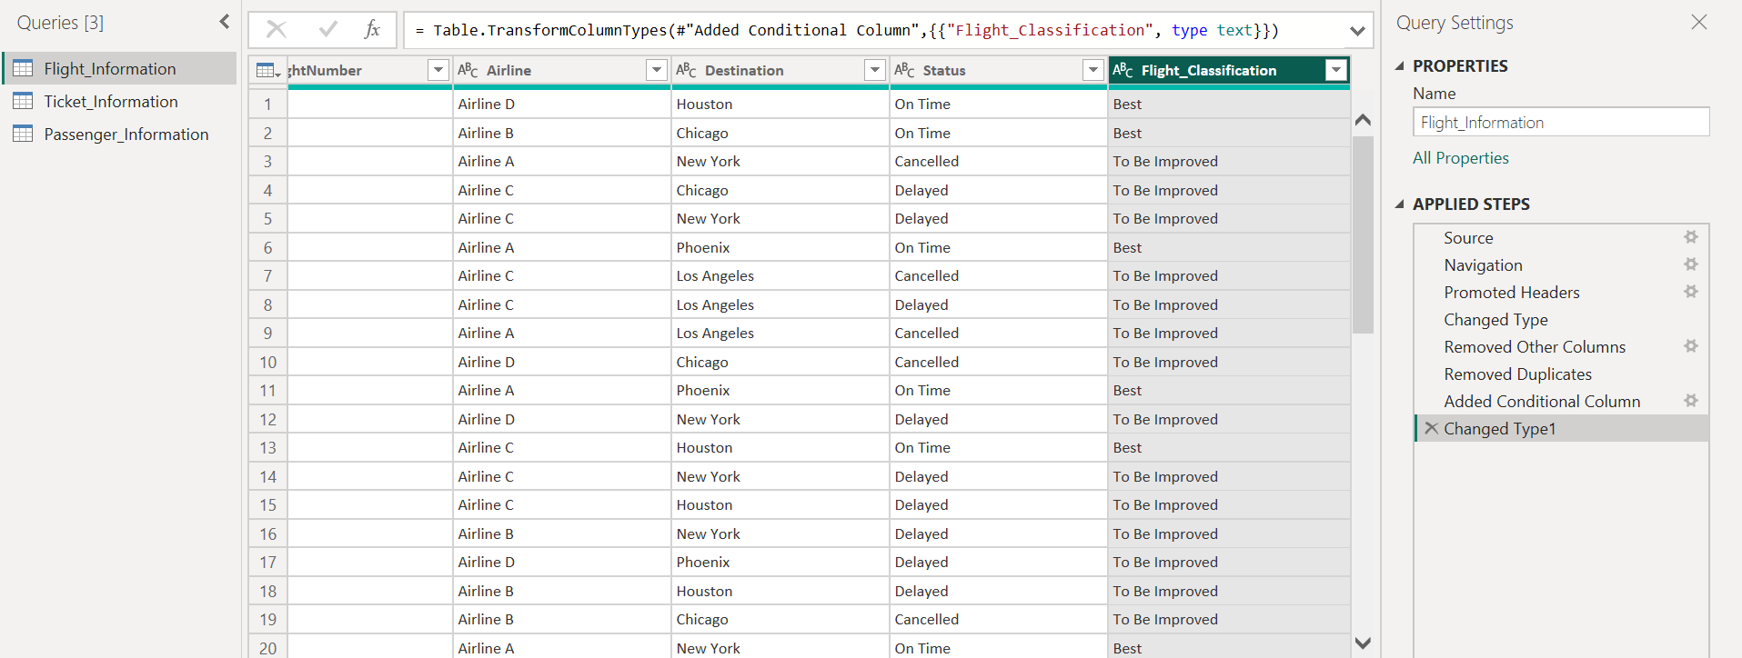

1. **Extracting Flight Numbers Using "Column from Examples"**

To extract the numeric portion from the FlightNumber column:

1. Select the FlightNumber Column.
2. Go to Add Column → Column from Examples → From Selection. Create the Example Column.
3. In the new column, type the flight number manually for the first row (e.g., the FlightNumber is "FL102", type 102). Power BI will automatically detect the pattern and extract flight numbers from the entire column.
4. Finalize the Column

Rename the new column as Flight_Number_Extracted. Set the column’s data type to Whole Number for proper calculations.

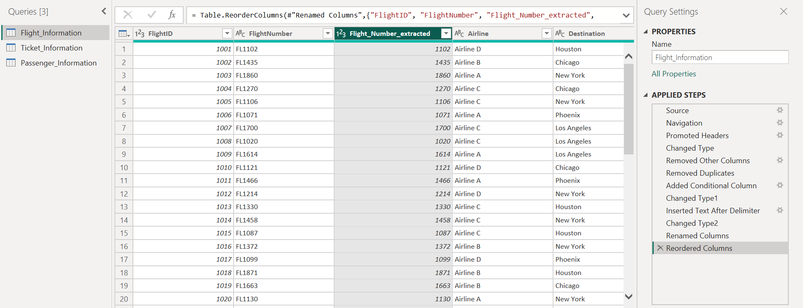

**Tasks (4)**

Calculations Using DAX

● Calculate:

* Total passengers for a specific flight.
* Total tickets booked.
* Filtered table showing "Best" flights only.

**Explication: (4)**

1. Click on home 🡪 Enter Data 🡪 (Name) Measure.
2. Right click on measure 🡪 new measure
3. DAX Formula: **Total_Passengers_by_FlightID =**

**CALCULATE(COUNTROWS('Passenger_Information'),FILTER('Passenger_Information', 'Passenger_Information'[FlightID] = VALUE("1157")))**

1. Total tickets booked DAX formula : **Total_ticket_booked = COUNT(Ticket_Information[TicketID])**
2. For “Best” flight create a new table DAX : **best_flights = FILTER(Flight_Information,Flight_Information[Flight_Classification]="Best")**
3. For visual select table from visualization pane then drag the created measurements in data columns.

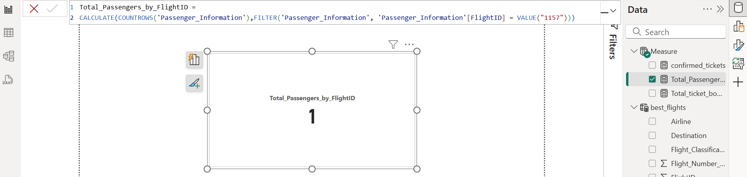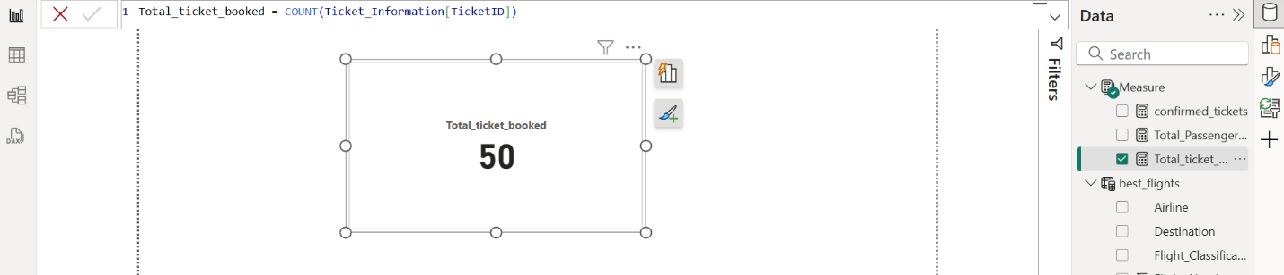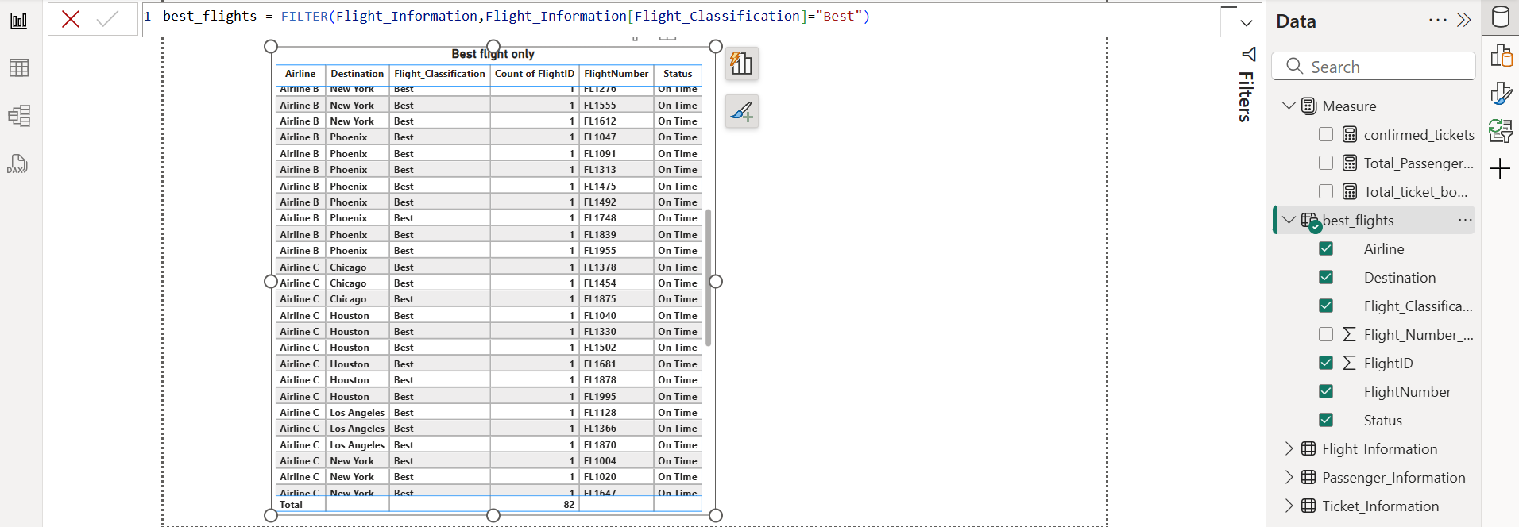

**Tasks (5)**

Visualization and Interactive Features

● Create visuals for:

○ Passenger count by airline.

○ Ticket booking statuses.

○ Flights by airline and destination.

● Add interactive features for:

○ Destination and Airline.

○ Quick views.

○ Airline-specific pages.

● Deliverables: Screenshots of all visuals and interactive features**.**

**Explication: (5)**

* **A) Passenger Count by Airline:**
* Selected Bar Chart from visualization pane.
* Drag airline column from flight_Information to y-axis.
* Drag PassengerID from Passenger_Information to x-axis.

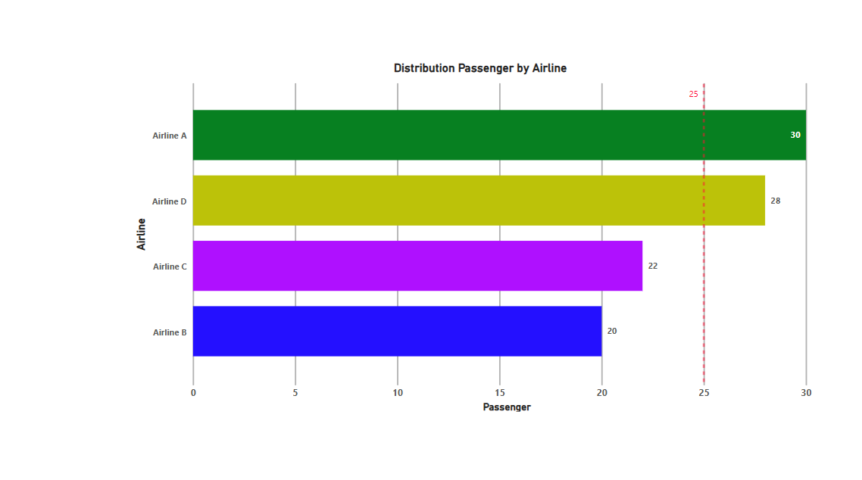

* **B) Ticket Booking Statuses:**
* Select Donut chart from the visualization pane.
* Drag BookingStatus column from the Ticket_Information to legend.
* And ticked_id to values section and converted into count both columns.

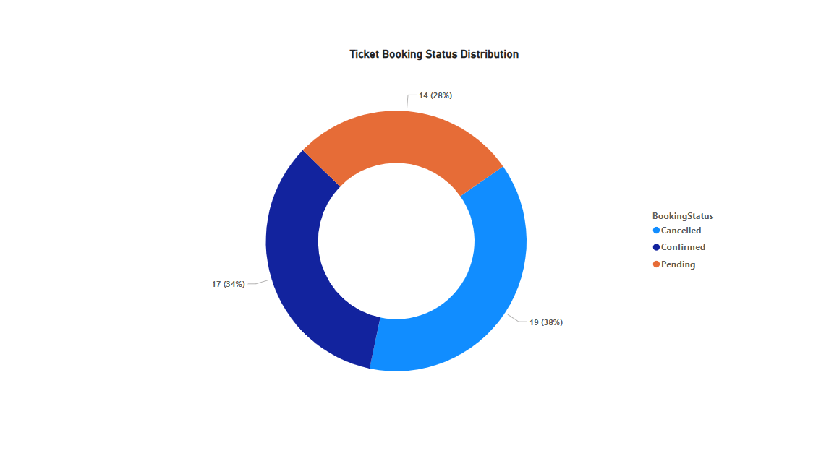

* **C) Flights by Airline and Destination:**
* Select matrix table from visualization pane.
* Drag from Flight_Information table columns airline 🡪 rows, Destination🡪 Columns and Flight_ID columns to value change aggregation to count.

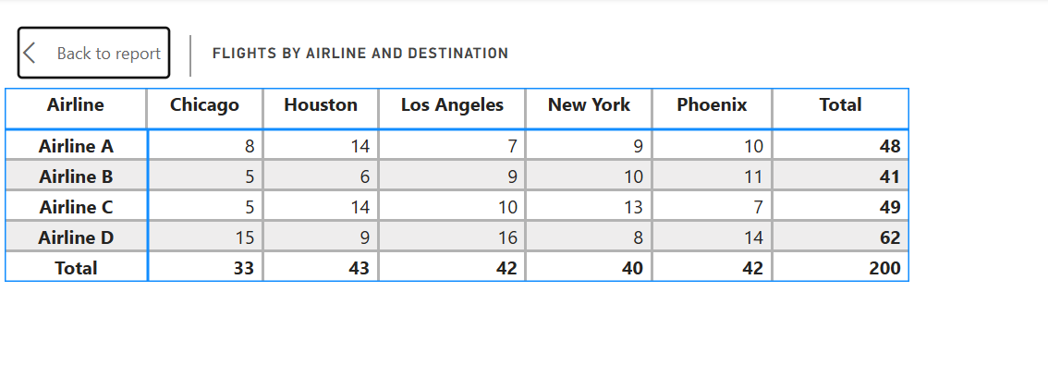

* **Adding Interactive Features**

1. **Destination and Airline Filters (Slicers)**

* Add slicers for:
* Flight_Information[Destination]
* Flight_Information[Airline]
* **Quick Views:**
* Create a Card Visual for key metrics such as:
* Total Flights.
* Total Passengers.
* Booking Status.
* Drag flightID column from flight_Iformation to Data (Total Flights) aggregation count.
* Drag PassengerID from Passenger_Information to data (Total Passenger) aggregation count.
* Drag TicketID from Ticket_Information to Data (BookingStatus) aggregation count.
* **Airline-Specific Pages:**
* Set the page type to "Drillthrough" in the Format pane.
* Drag Flight_Information[Airline] to the "Drill through from" section.
* Added all Visuals on Airline Details Page (Passenger count, Ticket status, etc.).
* Test Drill-Through:
* Go to the main dashboard.
* Right-click on an airline in a chart → Select Drill through → Airline Details.

**Tasks (6)**

* **Final Dashboard and Power BI Service**

1. Design a comprehensive dashboard with key visuals and insights.
2. Configure Row-Level Security (RLS) for Airline A data and assign it to a user.
3. Set up a schedule refresh at 5 PM daily.

**Explication: (6)**

1. **For Dashboard:**

* Open power BI service 🡪 clicked on my workspace
* Open the saved file which name was airline.
* In the menu bar click on three dots 🡪 select to pin to a dashboard.
* Create a new dashboard, the new dashboard name given “Airline Dashboard”.
* Then pin three pages to the dashboard.
* From edit option we change the Dashboard theme.

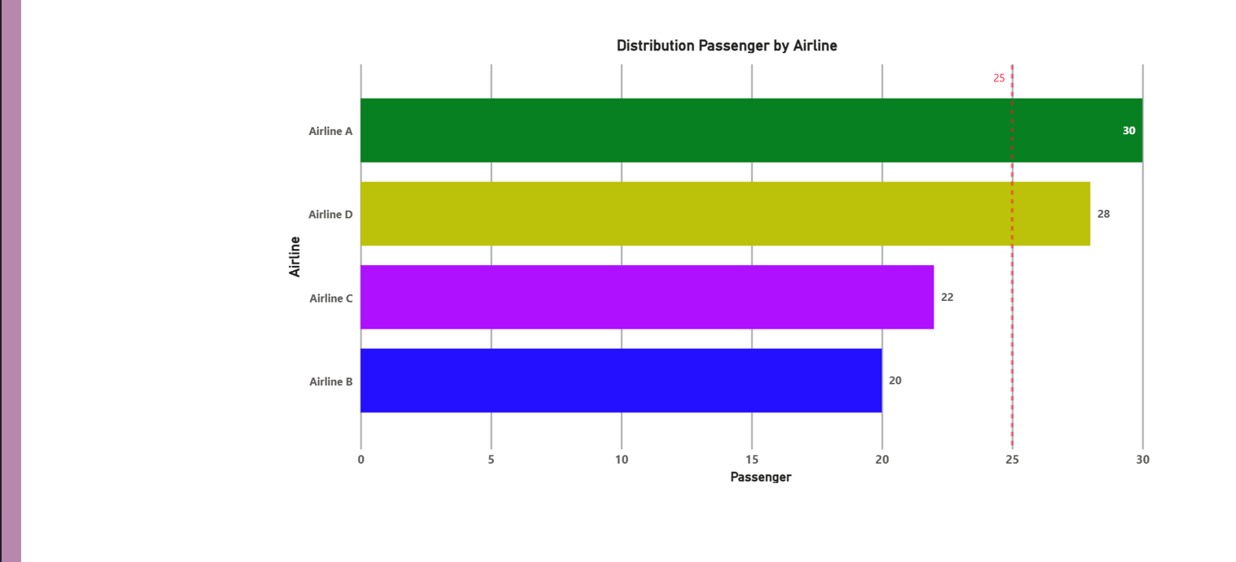

1. **For RLS:**

* Open Power BI Desktop and go to the Model View.
* Create a new role:
* Click Manage Roles → Create a Role → Name it "Airline_A".
* Apply filter to restrict data:
* Select the Flight_Information table.
* Enter this DAX filter: [Airline] = "Airline A"
* Click View As Roles in Power BI Desktop.
* Select "Airline_A" to confirm restricted access.
* Publish the report to Power BI Service.
* Go to Workspace → Security → Assign Users.
* Add the email of the user who should see only Airline A data.

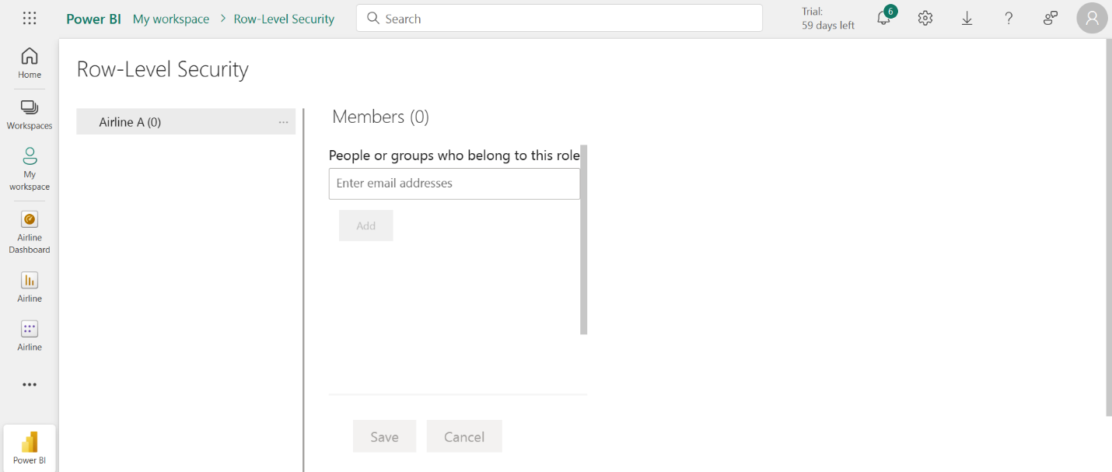

1. **schedule refresh:**

* Publish the report to Power BI Service.
* Go to Datasets 🡪 Select the dataset.
* Go to the setting 🡪 Power BI setting.
* Select 🡪 Semantic Model 🡪 Refresh.
* Select the time zone 🡪 Refresh frequency select daily.
* Set the time zone 5:00 PM 🡪 Apply.

